
COLLEGE OF SCIENCE AND TECHNOLOGY
SCHOOL OF INFORMATION AND COMMUNICATION TECHNOLOGY
DEPARTMENT OF COMPUTER AND SOFTWARE ENGINEERING
INDUSTRIAL ATTACHMENT REPORT
Academic Year 2026/2027

DESIGN, DEVELOPMENT AND DEPLOYMENT OF THE
EUCL WELLNESS MANAGEMENT SYSTEM AND ITS
MONITORING & EVALUATION (M&E) TOOL

Host organisation: REG/EUCL Ltd Headquarters
Period: 14th September 2026 – 6th November 2026 (8 weeks)
Submitted by: | TUMUKUNDE Gentille
Registration Number: | 223021200
Programme: | BSc (Hons) in Computer and Software Engineering
Academic Supervisor: | Mr Janvier GASUHUKE
Industrial Supervisor: | Mr Fabrice MUSANA
A report submitted in partial fulfilment of the requirements for the award of the Bachelor of Science (Honours) Degree in Computer and Software Engineering
Kigali, November 2026

DECLARATION
I, TUMUKUNDE Gentille, Registration Number 223021200, a student in the Department of Computer and Software Engineering, School of ICT, College of Science and Technology, University of Rwanda, hereby declare that this Industrial Attachment report is my own original work. It is a true account of the activities I carried out during my industrial attachment at REG/EUCL Ltd from 14th September 2026 to 6th November 2026. To the best of my knowledge, it has not been submitted, in whole or in part, to any other university or institution for any academic award. All the sources of information used in this report have been duly acknowledged in the references.

Student: TUMUKUNDE Gentille
Signature: ……………………………………… Date: ……/……/2026
Approved by:
Academic Supervisor: Mr Janvier GASUHUKE
Signature: ……………………………………… Date: ……/……/2026
Industrial Supervisor (REG/EUCL Ltd): Mr Fabrice MUSANA
Signature: ……………………………………… Date: ……/……/2026

DEDICATION

I dedicate this report to my beloved parents and family, whose love, sacrifices, prayers and constant encouragement have carried me throughout my studies;
to my lecturers and mentors, who opened the doors of knowledge for me;
and to all my friends and classmates, with whom I shared the joys and challenges of learning.

ACKNOWLEDGEMENT
First and foremost, I thank the Almighty God for the life, health, strength and wisdom He gave me throughout my studies and during this industrial attachment.
I sincerely thank the University of Rwanda, College of Science and Technology (UR-CST), through the School of ICT and the Department of Computer and Software Engineering, for organising the industrial attachment programme, which gave me the opportunity to put into practice the knowledge acquired in class.
My deep gratitude goes to the management of Rwanda Energy Group (REG) and the Energy Utility Corporation Limited (EUCL) for accepting me as an intern and for providing a conducive working environment. I am especially grateful to my industrial supervisor, Mr Fabrice MUSANA, for the guidance, the clear requirements, the regular reviews and the constructive comments that shaped the EUCL Wellness Management System into a professional product.
I also thank my academic supervisor, Mr Janvier GASUHUKE, for the follow-up, the advice and the visit made to me at the workplace on 29th October 2026. My thanks also go to the members of the panel who attended my presentations and whose comments greatly improved the quality of the system.
Finally, I am grateful to my family, my classmates and the staff of REG/EUCL Ltd for their support, collaboration and encouragement throughout these eight weeks. May God bless you all.

ABSTRACT
This report presents the industrial attachment I carried out at REG/EUCL Ltd, in Kigali, from 14th September 2026 to 6th November 2026, as a requirement of the Bachelor of Science (Honours) in Computer and Software Engineering at the University of Rwanda, College of Science and Technology. The main assignment of the attachment was to design, develop, test and host the EUCL Wellness Management System, a web application through which EUCL employees use wellness services (gym, swimming, massage, yoga and others) at partner companies, the companies record the services used, and EUCL pays each company for the services consumed by its employees.
The system was built with Django and Django REST Framework for the backend, a MySQL database, JSON Web Token (JWT) authentication and a React (Vite) frontend. Access is controlled by permissions grouped into roles (Super admin, HR, Employee, Company boss, Receptionist and M&E officer). The main features include company and service management with soft delete, employee onboarding with Excel upload, recording of services used with a rule of one company per employee per day, usage records with filters, payments and balances, PDF and Excel exports, employee feedback and a history of price changes. A separate Monitoring and Evaluation (M&E) tool was also developed with Django, PostgreSQL, Celery, Redis, HTMX and Chart.js; it synchronises the wellness data every 30 minutes and provides dashboards, eleven performance indicators with targets, and automatic PDF and Excel reports.
The work followed an iterative and incremental approach: the system was presented to the supervisor and a panel three times, and each set of comments was implemented in the following week. Both applications were tested with automated tests and browser tests and were finally deployed on the Railway cloud platform. The attachment strengthened my skills in full-stack web development, database design, security, testing and cloud deployment, and it ends with recommendations to the organisation, to the university and to future trainees.
Keywords: industrial attachment, wellness management, Django REST Framework, React, role-based access control, monitoring and evaluation, cloud deployment.

TABLE OF CONTENTS

DECLARATION i
DEDICATION ii
ACKNOWLEDGEMENT iii
ABSTRACT iv
TABLE OF CONTENTS v
LIST OF TABLES viii
LIST OF FIGURES ix
LIST OF SYMBOLS AND ABBREVIATIONS x
LIST OF APPENDICES
A1. A copy of a signed acceptance form 40
A2. Weekly filled and signed Log Book Schedule, with stamp 41
A3. The site training officer filled form, i.e. the Training Certificate 57
CHAPTER 1. INTRODUCTION 1
1.1 Background and necessity of the training 1
1.2 Training objectives 1
1.3 Training pre-requisites 2
1.4 Site selection 2
1.5 Training benefits and motivation 3
CHAPTER 2. LITERATURE REVIEW 4
2.1. Class theories related to site training 4
2.1.1 Software Development Life Cycle and iterative development 4
2.1.2 Requirements engineering 4
2.1.3 Client–server architecture and RESTful web services 4
2.1.4 The Model–View–Template pattern and the Django framework 5
2.1.5 Relational database design 5
2.1.6 Authentication, authorisation and Role-Based Access Control 5
2.1.7 Single Page Applications and the React library 6
2.1.8 User interface design, usability and responsive design 6
2.1.9 Data warehousing, ETL and incremental synchronisation 6
2.1.10 Asynchronous task processing and message brokers 7
2.1.11 Monitoring and Evaluation and performance indicators 7
2.1.12 Software testing 7
2.1.13 Containerisation, cloud deployment and cross-origin requests 7
2.1.14 Web application security 8
2.2. Description of the training activities 8
CHAPTER 3. MATERIALS AND METHODS 10
3.1. Site description 10
3.1.1 Site localization 10
3.1.2 Brief description of the company 10
3.2 Brief description of the site tools and equipment 11
3.3 Exposure of the used methodology 12
3.3.1 Site visit 12
3.3.2 Required training information and data collection 12
3.3.3 Questionnaire and interview 13
3.3.4 Site illustrations 13
3.3.5 Site works 14
3.3.6 Books and e-documentation 14
CHAPTER 4. TRAINING OUTCOMES 16
4.1. Survey map 16
4.2 Description of the training activities 17
4.2.1 Overview and architecture of the systems 17
4.2.2 Database design 17
4.2.3 Week 1 (14/09/2026 – 18/09/2026): requirements, environment, database and secure login 18
4.2.4 Week 2 (21/09/2026 – 25/09/2026): core features and Presentation 1 19
4.2.5 Week 3 (28/09/2026 – 02/10/2026): professional redesign and comments of Presentation 1 19
4.2.6 Week 4 (05/10/2026 – 09/10/2026): HR role, users and roles, payments and Presentation 2 21
4.2.7 Week 5 (12/10/2026 – 16/10/2026): the EUCL version of the system and Presentation 3 22
4.2.8 Week 6 (19/10/2026 – 23/10/2026): company accounts, role switches, rules, testing and documentation 23
4.2.9 Week 7 (26/10/2026 – 30/10/2026): the M&E tool and improvement of the wellness system 25
4.2.10 Week 8 (02/11/2026 – 06/11/2026): permissions refinement and hosting on Railway 27
4.2.11 Roles of the final system 29
4.2.12 Summary of the work done 29
4.3 Discussions and analysis of the training works 30
4.3.1 Achievement of the objectives 30
4.3.2 Evolution of the system through the presentations 30
4.3.3 Analysis of the main design decisions 31
4.3.4 Testing results 31
4.3.5 Challenges encountered and solutions 32
4.4 Environmental aspects of the training 32
4.5 Benefit/cost analysis of the training 33
CHAPTER 5. CONCLUSION AND RECOMMENDATIONS 35
5.1 Conclusion 35
5.2 Recommendations 35
5.2.1 Useful remarks 35
5.2.2 Suggestions to the organization 35
5.2.3 Recommendations towards the future trainings 36
REFERENCES 37
APPENDICES 39

LIST OF TABLES

Table 1: Overview of the training activities and the theories applied 8
Table 2: Tools, equipment and technologies used during the training 11
Table 3: Indicators calculated by the M&E tool 25
Table 4: Built-in roles of the EUCL Wellness Management System 29
Table 5: Summary of the eight weeks of training 29
Table 6: Main comments from the presentations and actions taken 30
Table 7: Challenges encountered and solutions adopted 32
Table 8: Costs of the training 33

LIST OF FIGURES

Figure 1: Location of REG/EUCL Ltd headquarters in Kigali 10
Figure 2: Organisational structure of REG/EUCL Ltd 11
Figure 3: The trainee at work at REG/EUCL Ltd 14
Figure 4: Work plan of the eight weeks of the training 14
Figure 5: Navigation map of the EUCL Wellness Management System 16
Figure 6: Architecture of the wellness system and the M&E tool 17
Figure 7: Entity Relationship Diagram of the wellness database 18
Figure 8: Sign-in page of the wellness system 19
Figure 9: First version of the super admin dashboard 19
Figure 10: Redesigned super admin dashboard 20
Figure 11: Dark mode and responsive view of the dashboard 20
Figure 12: Company management with soft delete and restore 21
Figure 13: Users and roles management page 21
Figure 14: Payments and balances per company 22
Figure 15: Places and services as seen by an EUCL employee 23
Figure 16: Company dashboard and recording of services used 23
Figure 17: Usage records with filters and exported statement 23
Figure 18: Company staff roles with on/off switches 24
Figure 19: Employees attendance page 24
Figure 20: Service history of an employee as seen by the admin 24
Figure 21: Data synchronisation between the wellness system and the M&E tool 25
Figure 22: Overview dashboard of the M&E tool 26
Figure 23: Indicators and targets in the M&E tool 27
Figure 24: Upload of EUCL employees from an Excel template 27
Figure 25: Employee feedback and history of price changes 27
Figure 26: Services of the project deployed on Railway 28
Figure 27: The EUCL Wellness Management System online 28
Figure 28: Hours worked per week 30

LIST OF SYMBOLS AND ABBREVIATIONS
Abbreviation | Meaning
API | Application Programming Interface
CORS | Cross-Origin Resource Sharing
CRUD | Create, Read, Update and Delete
CSE | Computer and Software Engineering
CSRF | Cross-Site Request Forgery
CST | College of Science and Technology
DRF | Django REST Framework
EDCL | Energy Development Corporation Limited
ERD | Entity Relationship Diagram
ETL | Extract, Transform and Load
EUCL | Energy Utility Corporation Limited
FK | Foreign Key
HR | Human Resources
HTML | HyperText Markup Language
HTMX | HTML extension library for dynamic pages without heavy JavaScript
HTTP(S) | HyperText Transfer Protocol (Secure)
IA | Industrial Attachment
ICT | Information and Communication Technology
JSON | JavaScript Object Notation
JWT | JSON Web Token
KPI | Key Performance Indicator
M&E | Monitoring and Evaluation
MVT | Model–View–Template
ORM | Object-Relational Mapping
PaaS | Platform as a Service
PDF | Portable Document Format
PK | Primary Key
RBAC | Role-Based Access Control
REG | Rwanda Energy Group
REST | Representational State Transfer
RWF | Rwandan Franc
SDLC | Software Development Life Cycle
SPA | Single Page Application
SQL | Structured Query Language
UI / UX | User Interface / User Experience
UR | University of Rwanda
URL | Uniform Resource Locator

CHAPTER 1. INTRODUCTION

1.1 Background and necessity of the training
The Industrial Attachment (IA) is a compulsory module of the Bachelor of Science (Honours) programme in Computer and Software Engineering at the University of Rwanda, College of Science and Technology (UR-CST). It places students in a real working environment so that they can apply the theories learnt in class, understand how professional organisations work, and acquire the practical skills, discipline and attitudes that employers expect from engineers.
Classroom learning gives a strong foundation in programming, databases, networks, software engineering and security, but many skills can only be developed on a real project: understanding the needs of real users, working with a supervisor who reviews the work regularly, changing a design when the requirements change, testing a system seriously, and putting it online so that people can use it. The industrial attachment fills this gap between theory and practice.
My attachment took place at REG/EUCL Ltd for eight weeks, from 14th September 2026 to 6th November 2026. EUCL offers its employees access to wellness services such as the gym, swimming, massage and yoga at partner companies, and EUCL pays the companies for the services its employees use. Managing such a programme involves many partner companies, many employees, many services with different prices, daily records of the services used and regular payments. Without a dedicated system, it is difficult to know who used which service, where, when and at what cost, to check what EUCL owes each company, and to evaluate whether the programme reaches its goals. This need justified the main assignment of my training: the design, development, testing and hosting of the EUCL Wellness Management System and of its Monitoring and Evaluation (M&E) tool.

1.2 Training objectives
General objective: to acquire practical experience in software engineering by designing, developing, testing and deploying a complete web-based system that solves a real need of the host organisation.
Specific objectives:
- To analyse the requirements of the EUCL wellness programme together with the industrial supervisor;
- To design a relational database for companies, services, employees, services used (visits), payments, roles and permissions;
- To develop a secure REST API with Django, Django REST Framework and JSON Web Token authentication;
- To develop a professional, responsive React frontend with a dedicated area for each type of user;
- To implement flexible, permission-based access control (roles that can be created and configured from the application);
- To produce reports and exports (PDF and Excel) for EUCL, HR and the partner companies;
- To develop a separate Monitoring and Evaluation tool with dashboards, indicators, targets and automatic reports;
- To test the systems with automated and browser tests, write the documentation and deploy both systems on a cloud platform;
- To develop professional skills: communication, presentations, time management, teamwork and responding to feedback.

1.3 Training pre-requisites
To carry out this training successfully, the following knowledge and requirements, mostly acquired during the previous years of study, were needed:
- Programming: Python and JavaScript, object-oriented programming and data structures;
- Database systems: relational modelling, normalisation, SQL and database management systems such as MySQL and PostgreSQL;
- Web technologies: HTML, CSS, HTTP, client–server architecture and web frameworks;
- Software engineering: requirements analysis, system design, UML, the software development life cycle and software testing;
- Information security: authentication, authorisation, password protection and secure handling of secret keys;
- Computer networks: IP addressing, DNS, HTTP(S) and basic understanding of servers and cloud hosting;
- Administrative requirements: the internship acceptance letter from REG/EUCL Ltd, the log book from the University, and a personal laptop with internet access.

1.4 Site selection
REG/EUCL Ltd was selected as the training site for the following reasons:
- It is a large national public company with many employees and many internal processes, which offers real problems that ICT can solve;
- It provides a professional environment with experienced supervisors who could guide and review my work;
- The proposed assignment, a full web system for the employee wellness programme, matched my field of Computer and Software Engineering and allowed me to apply almost all the modules studied;
- Its headquarters are located in Kigali, which was accessible for me during the whole period of the attachment.

1.5 Training benefits and motivation
The training was beneficial to the three parties involved:
To the trainee: I gained hands-on experience in full-stack development (Django, React), database design, security, automated testing and cloud deployment; I learnt to work with real requirements that change, to present my work to a panel and to respond to comments; and I improved my professional discipline and time management.
To the host organisation: REG/EUCL Ltd obtained a working, hosted system that digitises the management of its wellness programme, makes the usage and payments transparent, and provides indicators and reports for decision-making.
To the University: the attachment strengthens the link between UR-CST and industry, and the feedback from the organisation helps the University to adapt its programmes to the needs of the job market.
My motivation came from the desire to build a complete system that real people use every day, from the first requirement to the final online version, and to contribute to the wellbeing of the employees of a national institution.

CHAPTER 2. LITERATURE REVIEW
This chapter presents the theories learnt in class that were applied during the training (section 2.1), and then gives an overview of the training activities in relation to these theories (section 2.2).

2.1. Class theories related to site training

2.1.1 Software Development Life Cycle and iterative development
The Software Development Life Cycle (SDLC) is the structured process used to build software. Its main phases are requirements analysis, design, implementation, testing, deployment and maintenance (Sommerville, 2016). In the traditional waterfall model, these phases follow each other once. In iterative and incremental models, and in Agile methods in general, the system is built in short cycles: each cycle produces a working version that is shown to the users, and their feedback is used to plan the next cycle (Pressman & Maxim, 2020).
Iterative development was the most suitable approach for this training because the requirements of the wellness system evolved after each review. The work was organised in weekly cycles, and three formal presentations to the supervisor and the panel acted as review points at the end of the main iterations.

2.1.2 Requirements engineering
Requirements engineering is the process of discovering, documenting and validating what a system must do. Functional requirements describe the services the system provides (for example, “a receptionist records the services used by an employee”), while non-functional requirements describe qualities such as security, performance, usability and availability (Sommerville, 2016). Requirements are collected through interviews, observation, document analysis and prototypes, and are validated with the stakeholders. In this training, the requirements were collected from the industrial supervisor and refined through the comments of the panel at each presentation.

2.1.3 Client–server architecture and RESTful web services
In the client–server model, a client (here, the web browser) sends requests to a server that processes them and returns responses. Modern web applications often separate the frontend (user interface) from the backend (business logic and data), which communicate through an Application Programming Interface (API).
Representational State Transfer (REST), defined by Fielding (2000), is an architectural style for such APIs. Its main principles are: resources identified by URLs (for example /api/companies/), use of the standard HTTP methods (GET to read, POST to create, PUT/PATCH to update, DELETE to remove), stateless communication in which each request carries all the information needed (including the authentication token), and a uniform representation of data, usually in JSON. The wellness system exposes a REST API used by its React frontend and, in read-only mode, by the M&E tool.

2.1.4 The Model–View–Template pattern and the Django framework
Django is a high-level Python web framework that follows the Model–View–Template (MVT) pattern, a variant of Model–View–Controller (Django Software Foundation, 2026). The Model describes the data and is mapped to database tables by the Object-Relational Mapper (ORM); the View contains the logic that answers a request; and the Template produces the HTML shown to the user. Django also provides migrations (versioned changes to the database structure), an authentication system with secure password hashing, an administration interface and protection against common attacks.
Django REST Framework (DRF) extends Django for building APIs. Its serializers convert models to JSON and validate incoming data, its viewsets group the CRUD operations of a resource, and its permission classes decide whether a request is allowed (Encode OSS, 2026). In this project, Django + DRF served the wellness API, while the M&E tool used Django in the classic server-rendered MVT style.

2.1.5 Relational database design
A relational database organises data into tables (relations) linked by keys. Database design starts with a conceptual model, usually an Entity Relationship Diagram (ERD), which identifies entities, attributes and relationships (one-to-one, one-to-many, many-to-many). The model is then normalised to remove redundancy and avoid update anomalies (Elmasri & Navathe, 2016).
Integrity constraints protect the quality of the data: primary keys identify each row; foreign keys enforce valid relationships; unique constraints prevent duplicates (for example a unique e-mail per company or a unique employee ID); and check or composite unique constraints enforce business rules (for example, one record per employee, service and day). Two further techniques used in this project are soft delete, where a record is marked as archived instead of being physically removed so that its history is kept, and the denormalised copy of values that must not change afterwards, such as the price at the time a service was used.

2.1.6 Authentication, authorisation and Role-Based Access Control
Authentication verifies who a user is, while authorisation decides what the authenticated user may do. Passwords must never be stored in plain text; frameworks such as Django store salted hashes produced by slow algorithms (PBKDF2 by default).
A JSON Web Token (JWT), standardised in RFC 7519, is a compact, digitally signed token containing claims about the user (Jones, Bradley & Sakimura, 2015). After a successful login the server issues a short-lived access token, sent with every request, and a longer-lived refresh token used to obtain new access tokens. Because the token is signed, the server can trust it without keeping a session, which suits stateless REST APIs.
Role-Based Access Control (RBAC) assigns permissions to roles and roles to users, instead of giving permissions to each user individually (Sandhu, Coyne, Feinstein & Youman, 1996). This simplifies administration: changing a role changes the rights of all its users at once. A good practice, applied in this project, is that the code checks permissions and never fixed role names, so that new roles can be created from the application without changing the code.

2.1.7 Single Page Applications and the React library
A Single Page Application (SPA) loads one HTML page and then updates its content dynamically with JavaScript, giving a fast and smooth experience close to a desktop application. React is a JavaScript library for building user interfaces from reusable components; it keeps the interface synchronised with the application state and re-renders only what changes (Meta Platforms, 2026). React Router manages navigation between pages of the SPA, including protected routes that are only shown to authorised users. Vite is a modern build tool that provides a fast development server and optimised production builds.

2.1.8 User interface design, usability and responsive design
Usability is the degree to which users can achieve their goals effectively, efficiently and with satisfaction. Common principles include consistency, visibility of the system status, clear feedback on errors, and minimising the user's memory load (Nielsen, 1994). Responsive design adapts the layout to the screen size (phone, tablet or computer) using flexible grids and CSS media queries. A light/dark theme improves comfort in different lighting conditions. These principles guided the redesign of the dashboards after the first presentation.

2.1.9 Data warehousing, ETL and incremental synchronisation
A data warehouse is a database designed for analysis and reporting, separate from the operational (transactional) database (Kimball & Ross, 2013). Data is moved into it by an Extract, Transform, Load (ETL) process. Separating analysis from operations protects the performance of the operational system and allows the analytical system to have its own structure.
Instead of copying everything each time, an incremental synchronisation copies only the rows that changed since the last run, using a cursor such as a last-modified timestamp. A small overlap window prevents missing rows written at the same moment, and the process must be idempotent, meaning that running it twice gives the same result without duplicates. A periodic reconciliation compares identifiers to detect rows deleted at the source. All these principles were applied in the synchronisation of the M&E tool.

2.1.10 Asynchronous task processing and message brokers
Some tasks are too long or must run on a schedule, for example building a PDF report or synchronising data every 30 minutes. They are executed in the background by workers that take jobs from a queue managed by a message broker. Celery is a distributed task queue for Python; Celery beat schedules periodic tasks; and Redis, an in-memory data store, is commonly used as its broker (Celery Project, 2026). This keeps the web application responsive while heavy work is done in the background.

2.1.11 Monitoring and Evaluation and performance indicators
Monitoring is the continuous collection of data on the progress of a programme, while evaluation is the periodic assessment of whether the programme achieves its objectives. Monitoring and Evaluation relies on indicators: measurable variables, each with a definition, a calculation method, a target and a direction (whether a higher or a lower value is better) (Kusek & Rist, 2004). Comparing the actual value of each indicator with its target shows whether the programme is on track, at risk or off track. The M&E tool developed during the training applies these concepts to the wellness programme (participation rate, cost per visit, payment delay, etc.).

2.1.12 Software testing
Software testing checks that a system behaves as expected and helps to find defects early. Unit tests check small pieces of code in isolation, integration tests check that components work together (for example an API endpoint with the database), system or end-to-end tests check complete user scenarios, and acceptance tests confirm that the system meets the users' needs (Sommerville, 2016). Automated tests can be re-run after every change (regression testing), which gives confidence when modifying the system. Django provides a test framework that creates a separate test database for each run.

2.1.13 Containerisation, cloud deployment and cross-origin requests
A container packages an application with its dependencies so that it runs the same way on any machine; Docker builds containers from a Dockerfile (Docker Inc., 2026). Cloud Platform as a Service (PaaS) providers such as Railway run such containers and offer managed databases, so that developers do not manage servers themselves (Railway Corp., 2026).
Production deployment of a Django application requires a production web server such as gunicorn, a way to serve static files such as WhiteNoise, and configuration read from environment variables so that secrets are never written in the source code (the twelve-factor principle). When the frontend and the API are hosted on different addresses, the browser applies the same-origin policy, and the API must explicitly allow the frontend's address through Cross-Origin Resource Sharing (CORS).

2.1.14 Web application security
The OWASP Top 10 lists the most critical security risks of web applications, among them broken access control, cryptographic failures, injection, security misconfiguration and identification and authentication failures (OWASP Foundation, 2021). The main countermeasures applied in this training were: permission checks on every API endpoint and row-level filtering of data, hashed passwords and strong-password validation, use of the ORM to avoid SQL injection, secrets kept in .env files and environment variables, restricted allowed hosts and CORS origins, and the use of HTTPS in production.

2.2. Description of the training activities
The training activities covered the complete life cycle of the two systems. Table 1 summarises the main groups of activities, the period in which they took place and the class theories applied in each of them. The detailed description of the activities and of their results is given in Chapter 4.
Table 1: Overview of the training activities and the theories applied
Group of activities | Period | Main activities | Theories applied
Requirements analysis | Week 1, then after each presentation | Study of the brief, users and main features with the supervisor; analysis of panel comments | Requirements engineering (2.1.2)
Design | Weeks 1, 2 and 5 | Database design (ERD), architecture, API design, user areas | Database design, client–server, REST (2.1.3–2.1.5)
Backend development | Weeks 1–8 | Django models, migrations, DRF API, JWT login, permissions, payments, exports, feedback | MVT, DRF, RBAC, security (2.1.4, 2.1.6, 2.1.14)
Frontend development | Weeks 1–8 | React pages and dashboards, protected routes, responsive design, dark mode, PDF/Excel exports | SPA, React, usability (2.1.7, 2.1.8)
M&E tool | Week 7 | Separate Django application, data sync, dashboards, indicators, targets, reports | Data warehousing, Celery, M&E (2.1.9–2.1.11)
Testing | Weeks 2–8 | Automated tests, browser tests, bug fixing | Software testing (2.1.12)
Deployment | Week 8 | Docker, gunicorn, WhiteNoise, Railway, CORS, online tests | Cloud deployment (2.1.13)
Presentations and reporting | Weeks 2, 4, 5 and 7 | Three panel presentations, supervisor visit, documentation and weekly log book | Professional communication

CHAPTER 3. MATERIALS AND METHODS
This chapter describes the training site, the tools and equipment used, and the methodology followed during the eight weeks of the attachment.

3.1. Site description

3.1.1 Site localization
The training took place at the headquarters of Rwanda Energy Group Limited (REG) and its subsidiary, the Energy Utility Corporation Limited (EUCL). The headquarters are located along KN 82 Street (KN 82 St 3), in Nyarugenge District, City of Kigali, Rwanda (P.O. Box 537 Kigali). Their geographical coordinates are approximately 1°56′44″ S, 30°03′26″ E (Wikipedia, 2026). The trainee was attached to [Name of the Department / Unit where you were placed, e.g. ICT Department].

[INSERT SCREENSHOT HERE: Google Maps screenshot showing the location of REG/EUCL headquarters, KN 82 St, Nyarugenge, Kigali]

Figure 1: Location of REG/EUCL Ltd headquarters in Kigali

3.1.2 Brief description of the company
Rwanda Energy Group Limited (REG) is a government-owned company created in July 2014 to expand, maintain and operate the energy infrastructure of Rwanda. It works as a holding company with two wholly owned subsidiaries (REG, 2024):
- Energy Utility Corporation Limited (EUCL): responsible for the generation, transmission, distribution and retail of electricity, and for maintaining and improving power plants and networks so as to deliver electricity to consumers at a sustainable cost;
- Energy Development Corporation Limited (EDCL): responsible for developing new energy projects, including generation and electricity access projects.
REG works closely with the Ministry of Infrastructure to set and monitor the national energy goals, and its mission is to develop and provide reliable and affordable energy while creating value for its stakeholders. With a large workforce spread across the country, REG/EUCL pays attention to the wellbeing of its staff; the wellness programme, through which employees use wellness services at partner companies paid by EUCL, is one example. The EUCL Wellness Management System developed during this training supports this programme.

[INSERT SCREENSHOT HERE: Organisational chart of REG/EUCL Ltd (from the company website or documents), showing the department where you were placed]

Figure 2: Organisational structure of REG/EUCL Ltd

3.2 Brief description of the site tools and equipment
The training was mainly a software development assignment. Table 2 presents the equipment, software and technologies used, with the purpose of each.
Table 2: Tools, equipment and technologies used during the training
Category | Tool / technology | Purpose in the training
Hardware | Personal laptop [specify model, RAM, processor], internet connection | Development, testing and presentations
Operating system & shell | Windows, PowerShell | Running the development servers and commands
Code editor & version control | Visual Studio Code, Git | Writing code and keeping the history of changes
Backend | Python, Django 6, Django REST Framework 3.18, SimpleJWT | Wellness API, business rules and JWT authentication
Operational database | MySQL (with mysqlclient) | Storing companies, services, employees, visits, payments and roles
Frontend | React 19, Vite 8, React Router 7, axios | User interface, navigation and calls to the API
Exports | jsPDF, jspdf-autotable, write-excel-file, openpyxl | PDF and Excel statements; Excel template and upload of employees
M&E tool | Django 6 (server-rendered), HTMX, Chart.js | Dashboards, indicators, targets and reports
M&E data & jobs | PostgreSQL 17, Celery 5.6, Redis, WeasyPrint | Data warehouse, background sync and scheduled PDF/Excel reports
Deployment | Docker, Docker Compose, gunicorn, WhiteNoise, Railway | Packaging and hosting both systems online
Testing | Django test framework, web browser developer tools | Automated tests and browser (end-to-end) tests
Office tools | Microsoft Word, PowerPoint | Documentation, presentation slides and log book

3.3 Exposure of the used methodology
The training followed an iterative and incremental approach. Each week started with the plan agreed at the end of the previous week, continued with design and development, and ended with testing and a review of the results. At the end of weeks 2, 4 and 5 the system was formally presented to the supervisor and a panel, and the comments received became the requirements of the following week. The methods used to collect information and carry out the work are described below.

3.3.1 Site visit
At the beginning of the attachment, I was introduced to the working environment and to my industrial supervisor, with whom I studied the assignment, the users of the future system and its main features. Throughout the training, I worked at the site with regular follow-up by the supervisor. On Thursday, 29th October 2026, my academic supervisor from UR-CST visited me at the workplace; I presented the wellness system and the M&E tool, and we discussed the progress of my training.

3.3.2 Required training information and data collection
The information needed to build the system was collected from:
- the brief of the assignment and discussions with the industrial supervisor (who uses the system, what each user does, how EUCL pays the companies);
- the comments of the supervisor and the panel during the three presentations, which were listed, analysed and converted into tasks;
- the official documentation of the technologies used (Django, Django REST Framework, React, Celery, Railway), consulted to implement each feature correctly;
- demo data (companies, services with prices, employees and visits) prepared to test the system and to run the demonstrations, and, after hosting, the first real companies and employees added to the online system.

3.3.3 Questionnaire and interview
No written questionnaire was distributed. Information was instead gathered through informal interviews and review meetings with the industrial supervisor and through the question-and-answer sessions of the panel presentations. The main questions discussed were:
- Who are the users of the system, and what should each of them be able to see and do?
- How are partner companies added, and who defines their services and prices?
- How does EUCL decide which services it covers, and how much does it pay for each?
- How are the services used by an employee recorded and verified at the company?
- How many companies and services may an employee use in one day?
- What reports and statements do EUCL, HR and the companies need, and in which formats?
- Which figures are needed to monitor and evaluate the wellness programme?
The answers to these questions were used to define and later to adjust the business rules of the system, as described in Chapter 4.

3.3.4 Site illustrations
To illustrate and communicate the work, the following illustrations were produced: system architecture diagrams, an Entity Relationship Diagram of the database, a navigation map of the user areas, data-flow diagrams of the M&E synchronisation, charts of the work done, and screenshots of the system at each stage. Presentation slides were also prepared for each of the three panel presentations. These illustrations are presented in Chapter 4.

[INSERT SCREENSHOT HERE: Photo of the trainee at the workstation at REG/EUCL Ltd, or of a presentation session (optional)]

Figure 3: The trainee at work at REG/EUCL Ltd

3.3.5 Site works
The practical work consisted of designing, coding, testing and deploying the two systems. It was organised in eight weekly iterations, shown in Figure 4. Each iteration followed the same cycle: planning, design, implementation, testing, review and, at the end of the main iterations, a presentation.
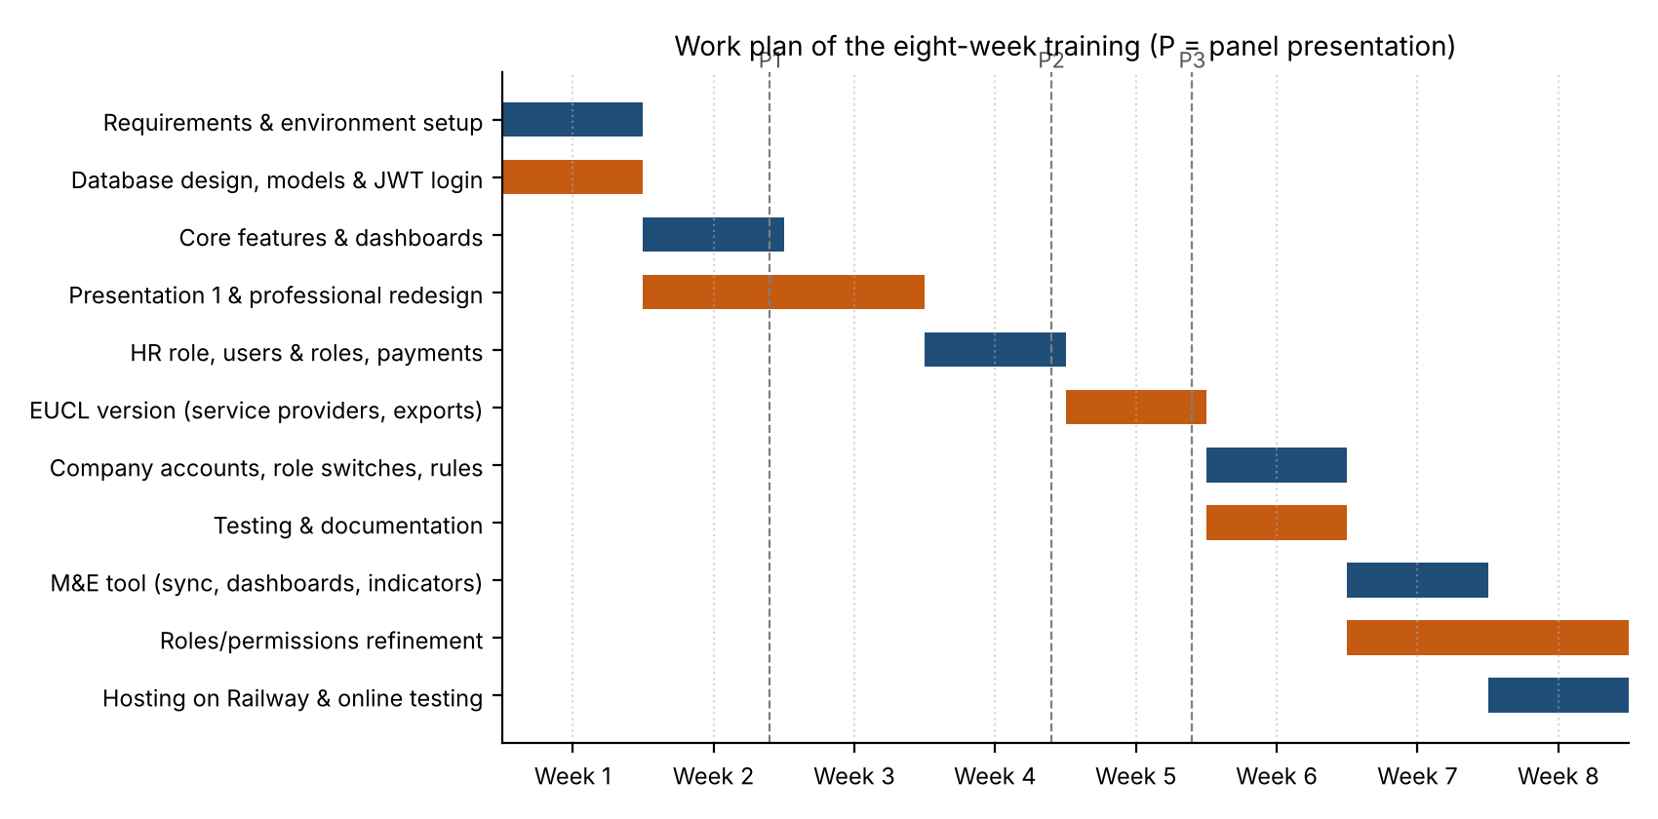
Figure 4: Work plan of the eight weeks of the training
The daily working schedule was about eight hours, generally split into two sessions of about four hours each, from Monday to Friday. In total, 288 hours were worked over 38 working days; the trainee was absent on Monday 14th September 2026 (acceptance letter not yet received) and on Monday 26th October 2026 (sickness), as recorded in the log book.

3.3.6 Books and e-documentation
Textbooks on software engineering and database systems were used to support the design decisions, while the official online documentation of Django, Django REST Framework, SimpleJWT, React, React Router, Vite, Celery, Redis, PostgreSQL, Docker and Railway was consulted daily during the implementation. The OWASP Top 10 guided the security measures. The complete list is given in the References.

CHAPTER 4. TRAINING OUTCOMES
This chapter presents the results of the training: the map of the system (4.1), the detailed description of the work done week by week (4.2), the discussion and analysis of the work (4.3), its environmental aspects (4.4) and its benefit/cost analysis (4.5).

4.1. Survey map
For a software project, the survey map is the map of the system: it shows the different user areas and the pages that each type of user can reach after signing in. The location of the site itself is shown in Figure 1. Figure 5 presents the navigation map of the EUCL Wellness Management System and its link with the M&E tool.
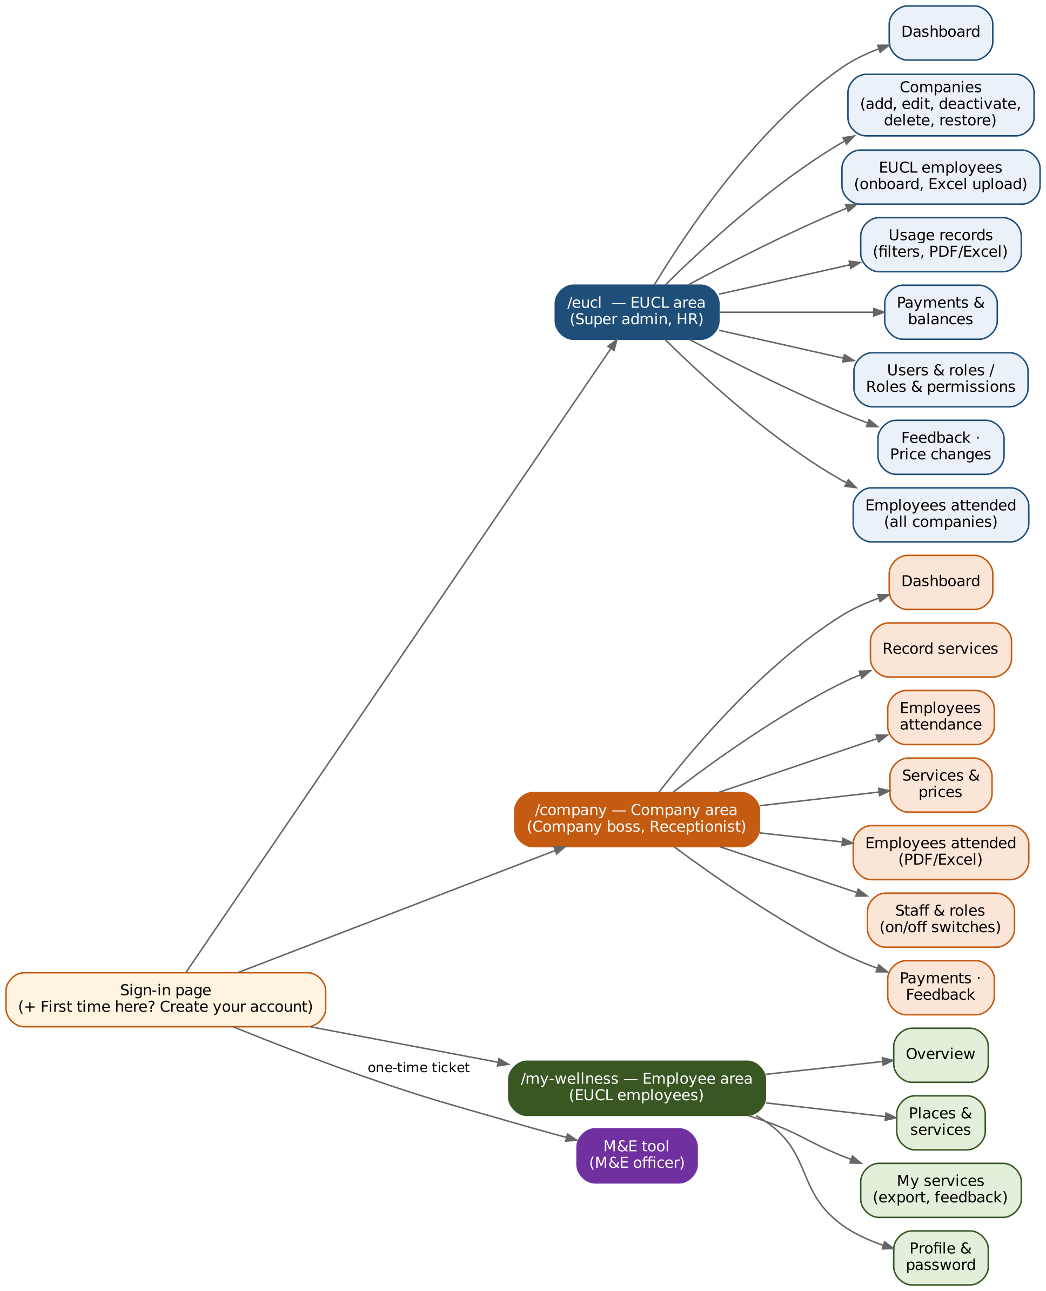
Figure 5: Navigation map of the EUCL Wellness Management System
After signing in, each user is sent to the area that matches the permissions of his or her role: the EUCL area (/eucl) for the super admin and HR, the Company area (/company) for the company boss and the receptionist, the Employee area (/my-wellness) for EUCL employees, and the M&E tool for M&E officers, who are signed in automatically with a one-time ticket.

4.2 Description of the training activities

4.2.1 Overview and architecture of the systems
Two separate applications were developed. The EUCL Wellness Management System is made of a React frontend and a Django REST API connected to a MySQL database. The M&E tool is a separate Django application with its own PostgreSQL database; it has no shared code or database with the wellness system and communicates with it only over HTTP, through the sign-in endpoints and a read-only export API. Its background jobs (synchronisation, reconciliation and reports) are run by Celery with Redis. Both applications are hosted on Railway. Figure 6 shows the architecture.
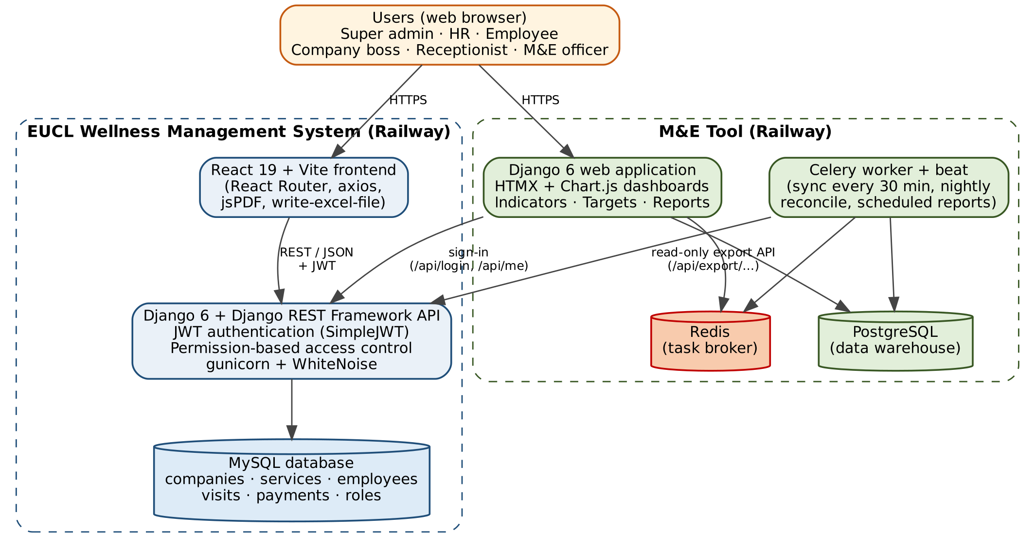
Figure 6: Architecture of the wellness system and the M&E tool

4.2.2 Database design
Figure 7 shows the main entities of the wellness database. A Company offers several Services, each with a price. An Employee is linked to a Django user account. Each service used by an employee at a company is a Visit, which keeps a copy of the company and of the price at the time it was recorded, so that the history stays correct even if a price or a name changes later. A Payment covers a period for a company and is linked to the visits it pays. Access rights are modelled by Permissions grouped into Roles, which are given to users through their UserProfile. Every change of price is kept in PriceChange.
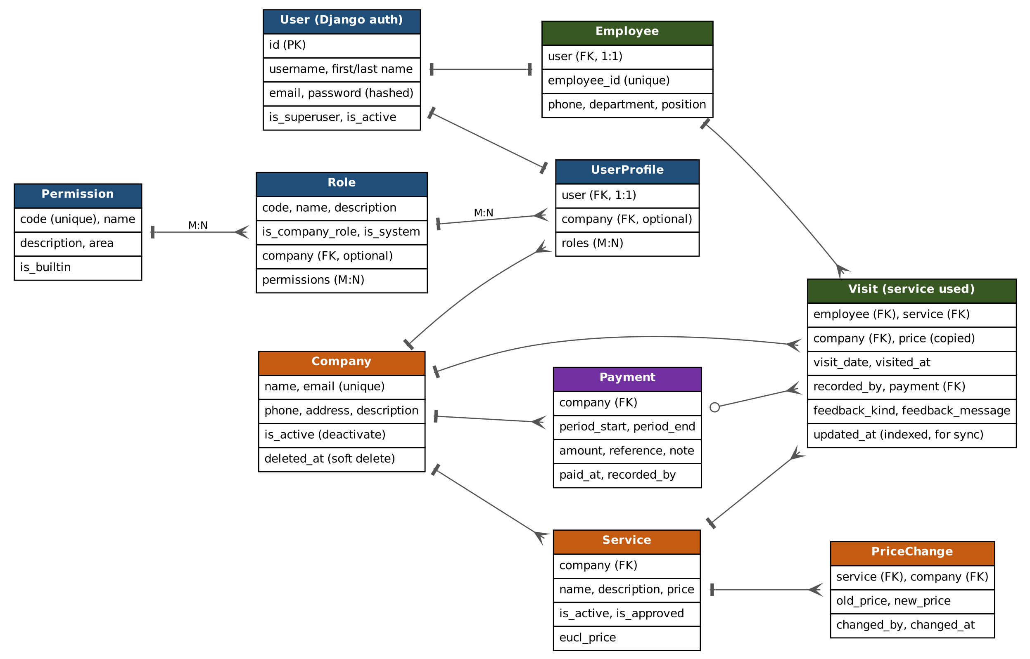
Figure 7: Entity Relationship Diagram of the wellness database
Important business rules are enforced directly in the database: a unique e-mail per company, a unique employee ID, and a constraint allowing only one record per employee, service and day. Companies are never erased: deactivating a company pauses it, and deleting it only archives it (soft delete); both actions can be undone.

4.2.3 Week 1 (14/09/2026 – 18/09/2026): requirements, environment, database and secure login
On Monday 14th September I was absent because I had not yet received the acceptance letter. From Tuesday, I analysed the requirements with my supervisor and installed and configured the development environment: Python, Django, Django REST Framework, MySQL and a Python virtual environment. I connected Django to MySQL and kept the secret key and passwords in a .env file instead of the source code.
I designed the database (companies, services, EUCL employees, visits and payments), created the Django models and migrations and checked the tables in the Django admin. I built a secure login using JSON Web Tokens with access and refresh tokens, tested the API endpoints and fixed a problem that prevented the super admin from logging in (solved by resetting the account). I then set up the React (Vite) frontend; the npm installation first failed because of a network error, which was solved by changing the internet connection. Finally, I built the sign-in page and the protected pages that send each user to the right dashboard.

[INSERT SCREENSHOT HERE: Sign-in page of the EUCL Wellness Management System]

Figure 8: Sign-in page of the wellness system

4.2.4 Week 2 (21/09/2026 – 25/09/2026): core features and Presentation 1
I built the dashboards for the super admin, the companies and the EUCL employees, and the reception page where a company records the visit of an EUCL employee. I developed company management (add, edit and list partner companies), the services each company offers with their prices, the EUCL employee registration form and list, and the visit history with search and date filters. On Thursday I tested all the pages end to end, fixed the blank-page errors and prepared the slides and demo data.
On Friday 25th September I gave Presentation 1 (about two hours) to the supervisor and the panel. The comments received were: give all the dashboards a professional look; bring all the functions of the Django admin into the super admin dashboard, on the same tab; ask for full credentials at employee registration; make the employee dashboard fully working (profile, password, visit history); and allow the super admin to see companies with their staff, edit them and delete them without losing their records or changing the counts.

[INSERT SCREENSHOT HERE: First version of the super admin dashboard (as shown in Presentation 1)]

Figure 9: First version of the super admin dashboard

4.2.5 Week 3 (28/09/2026 – 02/10/2026): professional redesign and comments of Presentation 1
I redesigned all the dashboards with a professional look (sidebar menu, cards, tables, light and dark mode) and made all the pages work on phones and tablets. I moved the Django admin functions into the super admin dashboard so that everything opens on the same tab. Companies can now be edited, deactivated, deleted and restored; deleting a company only archives it (soft delete), so its visits and payments are kept and the totals do not change.
Employee registration now asks for full credentials (names, e-mail, phone, department, position and password) and validates them: strong password, valid phone number, unique username and e-mail. The employee dashboard allows employees to edit their profile, change their password and see their visit history with filters. I also introduced dynamic roles: a user can have one or more roles and every page checks permissions instead of fixed role names. I wrote automated tests for these features and fixed the bugs found (menus and cards on small screens).

[INSERT SCREENSHOT HERE: Redesigned super admin dashboard (light mode) with sidebar, cards and tables]

Figure 10: Redesigned super admin dashboard

[INSERT SCREENSHOT HERE: The same dashboard in dark mode and/or on a phone screen]

Figure 11: Dark mode and responsive view of the dashboard

[INSERT SCREENSHOT HERE: Companies page showing the actions edit, deactivate, delete and restore]

Figure 12: Company management with soft delete and restore

4.2.6 Week 4 (05/10/2026 – 09/10/2026): HR role, users and roles, payments and Presentation 2
I added the EUCL HR role to onboard and manage EUCL employees and added daily wellness benefits that renewed every day for each employee. I built the Users & roles page, where the admin creates users, gives them roles, creates new roles dynamically and chooses their permissions, with a filter on the list. I then built the payments module: it calculates the amount for each service and the total that EUCL owes each company, allows a period to be marked as paid, and keeps the payment history. On Thursday I tested roles, benefits and payments and prepared the slides.
On Friday 9th October I gave Presentation 2. The comments were: rename the system “EUCL Wellness Management System” and remove the benefits; treat companies as places where EUCL employees use services, each company listing its services and employees seeing the places and services before they go; allow an employee to use many services in a day; add a filter icon and PDF export to the usage records; create a company dashboard for the boss and the receptionist, where the receptionist ticks the services used, with the payment amount per service; and allow the admin to deactivate a company and to filter the Users & roles list.

[INSERT SCREENSHOT HERE: Users & roles page (list of users with roles and filter icon)]

Figure 13: Users and roles management page

[INSERT SCREENSHOT HERE: Payments page showing amounts owed per company and the 'mark as paid' action]

Figure 14: Payments and balances per company

4.2.7 Week 5 (12/10/2026 – 16/10/2026): the EUCL version of the system and Presentation 3
Working on the comments of Presentation 2, I renamed the system EUCL Wellness Management System, removed the benefits and changed the database so that companies are service providers with their own services. EUCL chooses which services it covers at each company and the amount it pays for each, and employees see each place with its services marked as covered or not covered by EUCL.
Companies now have a dashboard for the boss and the receptionist. The receptionist ticks the services each employee used, and both can see the employees who attended, the services and the amounts, with the total. Usage records have a filter icon and a PDF export. EUCL can see how much it owes each company and export payment statements in PDF and Excel. When a company is deactivated, its staff see the message “This company has been deactivated! Please contact EUCL”.
On Friday 16th October I gave Presentation 3. The comments were: create the company's login when the company is added, let the company list its own services and let EUCL choose which ones its employees can use; give staff roles with on/off switches and allow new roles, with the Employees attendance page for the receptionist only; export Employees attended to Excel as well as PDF; allow an employee to visit only one company per day and remove the QR code from the employee dashboard; let the admin open an employee and see all the companies and services used, when, and the amount; and let companies see only the employees who visited them.

[INSERT SCREENSHOT HERE: Employee view of 'Places & services' with services marked covered / not covered by EUCL]

Figure 15: Places and services as seen by an EUCL employee

[INSERT SCREENSHOT HERE: Company dashboard (company boss) with the 'Record services' page where the receptionist ticks services]

Figure 16: Company dashboard and recording of services used

[INSERT SCREENSHOT HERE: Usage records page with the filter icon, and an example of the exported PDF / Excel payment statement]

Figure 17: Usage records with filters and exported statement

4.2.8 Week 6 (19/10/2026 – 23/10/2026): company accounts, role switches, rules, testing and documentation
When EUCL adds a company, the company's login is now created at the same time and shows the company's name, so each company has its own dashboard. The company lists the services it offers, and the Add service and Add staff actions were removed from the EUCL side. The company boss gives staff roles with on/off switches (All, Dashboard, Record visits, Services & prices, Employees attended, Employees attendance) and can add new roles. The Employees attendance page, reserved to receptionists, lists the EUCL employees so that reception can tick the services each one takes.
An employee can now use several services in a day but at only one company, a rule checked when recording. The QR code was removed from the employee dashboard. The admin can open an employee and see all the companies and services used, the dates and the amounts, while companies only see the employees who visited them. Employees attended can be exported to Excel as well as PDF. On Thursday I ran all 86 automated tests and the browser tests and fixed the bugs found. On Friday I wrote the documentation (setup guide, database migrations and how to run the system) and did a final review of the system.

[INSERT SCREENSHOT HERE: Company staff roles page with on/off permission switches]

Figure 18: Company staff roles with on/off switches

[INSERT SCREENSHOT HERE: Employees attendance page (receptionist ticking services for an EUCL employee)]

Figure 19: Employees attendance page

[INSERT SCREENSHOT HERE: Admin view of one employee: companies, services, dates and amounts]

Figure 20: Service history of an employee as seen by the admin

4.2.9 Week 7 (26/10/2026 – 30/10/2026): the M&E tool and improvement of the wellness system
On Monday 26th October I was absent because I was sick. On Tuesday I added a read-only export API and the M&E roles to the wellness system, and set up the M&E tool: a separate Django application with PostgreSQL, Celery and Redis that copies the wellness data every 30 minutes. Users sign in to the M&E tool with their wellness accounts and see only what their role allows. I built its dashboards with Chart.js: overview, per company and service performance. Figure 21 shows how the synchronisation works.
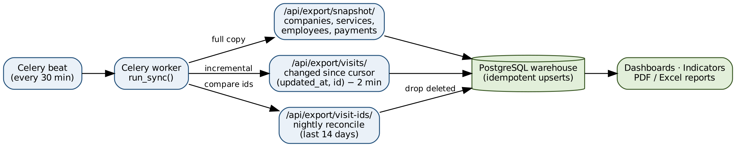
Figure 21: Data synchronisation between the wellness system and the M&E tool
Small tables (companies, services, employees and payments) are copied in full at each run, while visits are copied incrementally using a cursor on their last update time with a two-minute overlap; every night, the visits of the last 14 days are compared so that visits deleted in the wellness system also disappear from the M&E tool. Re-running a synchronisation never duplicates data. The M&E tool calculates the eleven indicators listed in Table 3; their targets are set on the Targets page, per month, for EUCL as a whole or for one company.
Table 3: Indicators calculated by the M&E tool
No. | Indicator | Definition | Better when
1 | Participation rate | Share of active EUCL employees who used at least one service in the month | Higher
2 | Services used | Number of services used by EUCL employees in the month | Higher
3 | Employees who used a service | Number of different employees who used at least one service | Higher
4 | Visits per participating employee | Average number of services used by each employee who came | Higher
5 | Repeat use | Share of last month's participants who came again this month | Higher
6 | Amount spent | What EUCL pays for the services used in the month | Lower
7 | Cost per visit | Average amount EUCL pays per service used | Lower
8 | Cost per participating employee | Average amount EUCL pays per employee who came | Lower
9 | Service coverage | Share of the services offered by companies that EUCL covers | Higher
10 | Still owed for the month | Amount for the month's services not yet paid by EUCL | Lower
11 | Payment delay | Average number of days from the end of a paid period to the payment | Lower

An indicator is shown on track when its target is met, at risk when it is within 10 % of the target, and off track beyond that. Reports in PDF and Excel are built in the background, and automatic daily, weekly and monthly reports can be scheduled.
On Wednesday I added a light/dark mode to both systems and renamed “visits” to “services” everywhere on screen. EUCL now pays the company's own price. The super admin can open a company and see which employees came, when and which services they used, by month. PDF and Excel exports now show the total number of services and the total, paid and unpaid amounts. I organised the roles (Super admin, Company boss, Receptionist, HR, M&E officer): HR downloads an Excel template and uploads employees in bulk, employees create their own account at their first sign-in, and a roles page lets EUCL switch each permission on or off.
On Thursday 29th October my academic supervisor visited me; I presented the wellness system and the M&E tool and we discussed my progress. I then tested and fixed the new roles and permissions. On Friday I added employee feedback (a comment or complaint on each service used, read by HR and by each company on their Feedback pages) and a price changes page that shows every change of a service price (old and new price, who changed it and when), together with an Edit service prices permission that lets receptionists change prices without adding or removing services.

[INSERT SCREENSHOT HERE: M&E tool overview dashboard with Chart.js charts]

Figure 22: Overview dashboard of the M&E tool

[INSERT SCREENSHOT HERE: M&E tool indicators / targets page showing on track, at risk and off track statuses]

Figure 23: Indicators and targets in the M&E tool

[INSERT SCREENSHOT HERE: HR page with 'Download Excel template' and 'Upload employees']

Figure 24: Upload of EUCL employees from an Excel template

[INSERT SCREENSHOT HERE: Employee feedback page (HR or company) and the Price changes page]

Figure 25: Employee feedback and history of price changes

4.2.10 Week 8 (02/11/2026 – 06/11/2026): permissions refinement and hosting on Railway
On Monday I added a page for HR that shows which EUCL employees used services at every company, what they used and the amounts, and I improved the EUCL employees page. On Tuesday I made each user have exactly one role, because every role has its own permissions, and Employee became one of the role choices; Feedback was removed from the Receptionist role. M&E officers now go straight to the M&E tool after signing in, as themselves, using a one-time sign-in ticket.
On Wednesday I fixed roles and permissions: any role can now have any permission, and HR, who is not linked to a company, chooses which company to open the company pages for. Built-in roles keep their type, and permission changes reach a signed-in account within 15 seconds. I then prepared the project for hosting (gunicorn, WhiteNoise, settings read from environment variables and a Dockerfile) and fixed the npm security warnings. On Railway I added the MySQL, PostgreSQL and Redis databases, deployed the wellness API and the React frontend, and created the super admin account.
On Thursday I connected the frontend sign-in to the online API (allowed web addresses through CORS and the API address) and tested signing in online. I then deployed the M&E tool on Railway with its PostgreSQL database, Redis and storage for reports, and set up its data synchronisation with the wellness system. On Friday I tested the whole system online (signing in with each role, recording services, the M&E dashboards and reports), fixed the issues found, added the first companies and employees, and shared the link of the system with my supervisor. The system is available at [insert the online link of the system].

[INSERT SCREENSHOT HERE: Railway project dashboard showing the deployed services (API, frontend, MySQL, PostgreSQL, Redis, M&E tool)]

Figure 26: Services of the project deployed on Railway

[INSERT SCREENSHOT HERE: The live system opened in the browser at its online address]

Figure 27: The EUCL Wellness Management System online

4.2.11 Roles of the final system
At the end of the training, access to the system is controlled by permissions, and each user has one role. Table 4 summarises the built-in roles; the super admin can create new roles and switch any permission on or off.
Table 4: Built-in roles of the EUCL Wellness Management System
Role | Belongs to | Main rights
Super admin | EUCL | Everything: companies, users and roles, all services used, payments, price changes, feedback
HR | EUCL | Onboard and manage EUCL employees, Excel template and upload, employees attended at all companies, feedback
Employee | EUCL | See partner places and covered services, see and export own services, send feedback, manage profile
Company boss | A company | All company pages: dashboard, record services, attendance, services & prices, employees attended, payments, staff and roles
Receptionist | A company | Dashboard, record services, employees attendance, services & prices, employees attended
M&E officer | EUCL | M&E dashboards, indicators and targets, reports and data export

4.2.12 Summary of the work done
Table 5: Summary of the eight weeks of training
Week | Period | Main work | Hours
1 | 14/09 – 18/09/2026 | Requirements, environment, database design, JWT login, React setup, sign-in (absent Monday) | 30
2 | 21/09 – 25/09/2026 | Role dashboards, recording visits, companies, services, employees, visit history, Presentation 1 | 38
3 | 28/09 – 02/10/2026 | Professional & responsive redesign, admin on one tab, soft delete, full credentials, dynamic roles, tests | 38
4 | 05/10 – 09/10/2026 | HR role, daily benefits, users & roles, payments, mark as paid, Presentation 2 | 38
5 | 12/10 – 16/10/2026 | EUCL version: service providers, covered services, company dashboard, exports, Presentation 3 | 38
6 | 19/10 – 23/10/2026 | Company accounts, role switches, attendance, one company per day, 86 tests, documentation | 38
7 | 26/10 – 30/10/2026 | M&E tool, roles & HR upload, exports with totals, feedback, price changes, supervisor visit (absent Monday) | 30
8 | 02/11 – 06/11/2026 | HR attended page, one role per user, M&E sign-in, permissions, hosting on Railway, online tests | 38
 | Total | 8 weeks, 38 working days | 288

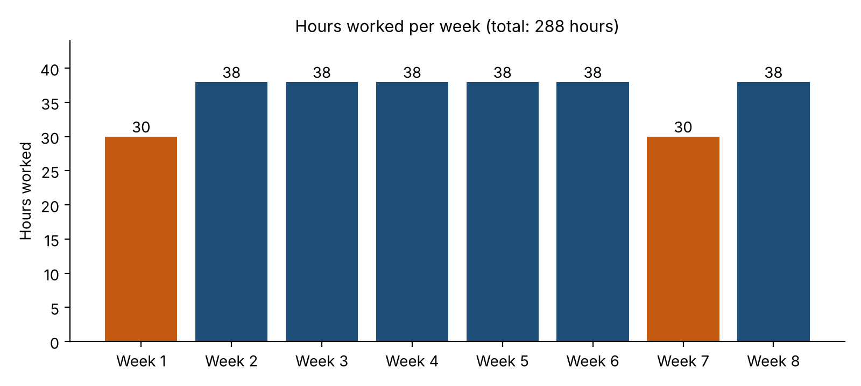
Figure 28: Hours worked per week

4.3 Discussions and analysis of the training works

4.3.1 Achievement of the objectives
All the specific objectives set in section 1.2 were achieved: the requirements were analysed and refined, the database and the API were designed and implemented, the frontend offers a professional area for each user, access is controlled by configurable permissions, reports and exports are available in PDF and Excel, the M&E tool was delivered, and both systems were tested, documented and hosted online.

4.3.2 Evolution of the system through the presentations
The three presentations played a central role in the quality of the final system. Table 6 shows how the main comments were implemented.
Table 6: Main comments from the presentations and actions taken
Presentation | Main comment | Action taken
1 (25/09) | Professional look of the dashboards | Full redesign: sidebar, cards, tables, light/dark mode, responsive pages (Week 3)
1 | Django admin functions inside the dashboard | All admin functions moved into the super admin dashboard, on the same tab
1 | Delete companies without losing records | Soft delete, deactivate and restore; history and counts preserved
1 | Full credentials and working employee dashboard | Complete registration with validation; profile, password and history pages
2 (09/10) | Rename the system, remove benefits | System renamed EUCL Wellness Management System; benefits removed (Week 5)
2 | Companies as service providers; employees see places | New database structure; covered / not covered services per place
2 | Company dashboard; receptionist ticks services | Company area for the boss and the receptionist with Record services
2 | Filters and PDF exports | Filter icon, PDF export, statements in PDF and Excel
3 (16/10) | Company login created with the company | Login created automatically when EUCL adds a company (Week 6)
3 | Staff roles with on/off switches | Switch-based permissions, “All” option and custom company roles
3 | One company per day; remove QR code | Rule enforced when recording; QR code removed
3 | Admin sees each employee's full history | Employee detail page; companies see only their own visitors

4.3.3 Analysis of the main design decisions
- Permissions instead of role names. Because the code checks permissions and never fixed role names, new roles were created and changed many times during the training without rewriting the code. This made the frequent changes requested by the panel easy to implement.
- Soft delete and copy of the price. Archiving companies instead of erasing them, and copying the company and the price into each visit, guarantee that the history, the totals and the payments remain correct even when companies, services or prices change.
- Rules in the database. Business rules such as one record per employee, service and day are enforced by database constraints, not only by the interface, which prevents double counting even in case of simultaneous requests.
- A separate M&E tool. Keeping the M&E tool separate, with its own database and a read-only export API, protects the performance and the security of the operational system, and the idempotent incremental synchronisation keeps the two systems consistent.
- Configuration through environment variables. Keeping secrets and addresses outside the code made the move from the development computer to Railway safe and simple.

4.3.4 Testing results
Testing was carried out continuously. Automated tests were written with the Django test framework for the API (authentication, permissions, companies, services, visits, payments, exports and business rules) and for each part of the M&E tool (accounts, synchronisation, dashboards, indicators, reports and monitoring). In week 6, the 86 automated tests of the wellness system all passed. As new features were added, the test suites kept growing: at the end of the training, the source code contained 161 automated test cases for the wellness system and 88 for the M&E tool. Browser tests were also done for each role, first locally and then on the hosted system, and all the bugs found were fixed.

4.3.5 Challenges encountered and solutions
Table 7: Challenges encountered and solutions adopted
Challenge | Solution
Late reception of the acceptance letter (absent on the first day) | Started on the second day and recovered the delay during the first week
npm installation failed because of a network error | Changed the internet connection and reinstalled the packages
The super admin could not log in | Reset the super admin account and re-tested the login
Blank pages in the frontend during the first end-to-end tests | Debugged with the browser developer tools and fixed the faulty pages
Menus and cards broken on small screens | Adjusted the responsive layout and tested on phone and tablet sizes
Frequent changes of requirements after each presentation | Iterative approach, permission-based design and automated tests to change the system safely
Change of the database structure in week 5 (companies as service providers) | New models and migrations, then full re-testing
Keeping the M&E data consistent with the wellness data | Incremental sync with overlap, idempotent upserts and nightly reconciliation
Frontend could not sign in to the online API | Configured the allowed origins (CORS) and the API address of the frontend
Absence due to sickness (26/10/2026) | Re-planned the tasks of the week to finish the M&E tool on time

4.4 Environmental aspects of the training
Although the training was a software project, its results have environmental aspects:
- Reduction of paper use: visits, attendance, payment statements and reports are recorded and produced electronically, and exported to PDF or Excel only when needed, instead of paper registers and printed forms.
- Less travel: HR, companies and EUCL can consult the information online, which reduces trips to exchange documents and verify payments.
- Efficient use of computing resources: the incremental synchronisation copies only the changed data, and the cloud platform shares its servers between many applications, which reduces the energy consumed compared with a dedicated server.
- Health and wellbeing of employees: by making the wellness programme easier to use and to monitor, the system supports the physical and mental health of EUCL staff, which is part of a healthy working environment.
- Ergonomics and electricity: long hours on the computer require good posture, regular breaks and turning off equipment when not in use; the dark mode also reduces eye strain and can reduce screen energy consumption.
No negative environmental impact of importance was identified, apart from the electricity consumed by computers and servers, which remains small and was used efficiently.

4.5 Benefit/cost analysis of the training
The costs of the training were mainly the time of the trainee and of the supervisors, and the resources used for development and hosting. Table 8 presents the main costs; the amounts that depend on the trainee's actual expenses are left to be completed.
Table 8: Costs of the training
Item | Description | Estimated cost (RWF)
Trainee's time | 288 hours over 38 working days | Not charged (academic training)
Transport | Daily transport to REG/EUCL headquarters for 38 days | [amount]
Internet | Internet bundles for development and documentation | [amount]
Laptop and electricity | Use of the personal laptop | [amount or 'own equipment']
Software | Python, Django, React, MySQL, PostgreSQL, Redis, VS Code, Git | 0 (free and open-source)
Cloud hosting | Railway hosting of the two systems and their databases | [monthly amount]
Printing and binding | Log book and final report | [amount]
Total |  | [total]

The benefits largely exceed these costs:
For REG/EUCL Ltd: a complete, hosted system built at very low cost thanks to open-source technologies; transparent records of who used which service, where, when and at what price; automatic calculation of what EUCL owes each company and of the payment history; ready-to-use statements in PDF and Excel; employee feedback on the quality of the services; and indicators with targets that support decisions on the wellness programme and its budget.
For the partner companies: their own dashboard to record services, manage their staff and prices, and follow the payments due by EUCL.
For the trainee: strong practical experience in full-stack development, databases, security, testing, data synchronisation and cloud deployment, plus professional skills in communication and presentations; a real project that can be shown to future employers.
For the University: a strengthened partnership with REG/EUCL Ltd and evidence that its curriculum prepares students for real industry work.

CHAPTER 5. CONCLUSION AND RECOMMENDATIONS

5.1 Conclusion
The industrial attachment at REG/EUCL Ltd, from 14th September to 6th November 2026, was a very rich experience. During these eight weeks I designed, developed, tested and hosted the EUCL Wellness Management System, which manages partner companies and their services, EUCL employees, the services they use, the payments due by EUCL, feedback and price changes, with a professional area for each type of user and permission-based access control. I also developed the M&E tool, which synchronises the wellness data, calculates eleven indicators against targets, and produces dashboards and reports. Both systems are online on Railway.
The training allowed me to apply many theories learnt in class, such as the software development life cycle, requirements engineering, REST architecture, database design, RBAC, software testing and cloud deployment, and to discover new tools and practices used in industry. The three presentations taught me to listen to users, accept criticism and turn comments into improvements. I can therefore conclude that the objectives of the training were achieved, both for me and for the host organisation.

5.2 Recommendations

5.2.1 Useful remarks
- Regular reviews and presentations are essential: each one significantly improved the system and avoided building features that users did not need;
- Designing for change (permissions instead of role names, soft delete, settings in environment variables) saves a lot of time when requirements evolve;
- Automated tests give the confidence to change a system quickly without breaking what already works;
- Good documentation (setup guide, how to run and deploy) is necessary for the handover and for the future maintenance of a system.

5.2.2 Suggestions to the organization
- Adopt the EUCL Wellness Management System officially, train HR, partner companies and employees on its use, and appoint a person responsible for its administration and maintenance;
- Use the M&E indicators and reports to set targets and evaluate the wellness programme every month;
- Plan for future improvements such as e-mail or SMS notifications, integration with the EUCL HR or payroll systems, single sign-on with EUCL accounts and a mobile application;
- Put in place regular backups of the databases, monitoring of the hosted services and periodic security reviews;
- Consider hosting the system on REG/EUCL infrastructure or on a cloud account owned by the organisation for long-term ownership;
- Continue to offer interns real projects with close supervision, as this benefits both the organisation and the students.

5.2.3 Recommendations towards the future trainings
To the University:
- Help students to obtain their acceptance letters early, so that they can start on the first day of the attachment;
- Strengthen practical modules on modern web frameworks, automated testing, Git, containers and cloud deployment;
- Continue the supervisors' visits to the workplace, which encourage the students and improve the follow-up.
To future trainees:
- Understand the requirements well before coding, and ask questions whenever something is not clear;
- Fill in the log book every day, keep the history of the work with Git and take screenshots at each stage for the report;
- Prepare presentations carefully, note all the comments and treat them as priorities;
- Be punctual, disciplined and open to learning new technologies.

REFERENCES
Celery Project. (2026). Celery: Distributed task queue documentation. https://docs.celeryq.dev/
Django Software Foundation. (2026). Django documentation. https://docs.djangoproject.com/
Docker Inc. (2026). Docker documentation. https://docs.docker.com/
Elmasri, R., & Navathe, S. B. (2016). Fundamentals of database systems (7th ed.). Pearson.
Encode OSS. (2026). Django REST framework documentation. https://www.django-rest-framework.org/
Fielding, R. T. (2000). Architectural styles and the design of network-based software architectures (Doctoral dissertation, University of California, Irvine).
Jones, M., Bradley, J., & Sakimura, N. (2015). JSON Web Token (JWT) (RFC 7519). Internet Engineering Task Force. https://www.rfc-editor.org/rfc/rfc7519
Kimball, R., & Ross, M. (2013). The data warehouse toolkit: The definitive guide to dimensional modeling (3rd ed.). Wiley.
Kusek, J. Z., & Rist, R. C. (2004). Ten steps to a results-based monitoring and evaluation system. The World Bank.
Meta Platforms. (2026). React documentation. https://react.dev/
Nielsen, J. (1994). Usability engineering. Morgan Kaufmann.
OWASP Foundation. (2021). OWASP Top 10: 2021. https://owasp.org/Top10/
PostgreSQL Global Development Group. (2026). PostgreSQL documentation. https://www.postgresql.org/docs/
Pressman, R. S., & Maxim, B. R. (2020). Software engineering: A practitioner's approach (9th ed.). McGraw-Hill Education.
Railway Corp. (2026). Railway documentation. https://docs.railway.com/
Rwanda Energy Group. (2024). Consolidated annual report and financial statements for the year ended 30 June 2024. https://www.reg.rw/
Sandhu, R. S., Coyne, E. J., Feinstein, H. L., & Youman, C. E. (1996). Role-based access control models. IEEE Computer, 29(2), 38–47.
Simple JWT contributors. (2026). Simple JWT documentation. https://django-rest-framework-simplejwt.readthedocs.io/
Sommerville, I. (2016). Software engineering (10th ed.). Pearson.
Vite contributors. (2026). Vite documentation. https://vite.dev/
Wikipedia. (2026). Rwanda Energy Group. https://en.wikipedia.org/wiki/Rwanda_Energy_Group

APPENDICES

